**Starting** [**The Python Challenge**](http://www.pythonchallenge.com/)

Clicking ‘…get challenged…’ takes you to this page:

[www.pythonchallenge.com/pc/def/0.html](http://www.pythonchallenge.com/pc/def/0.html)

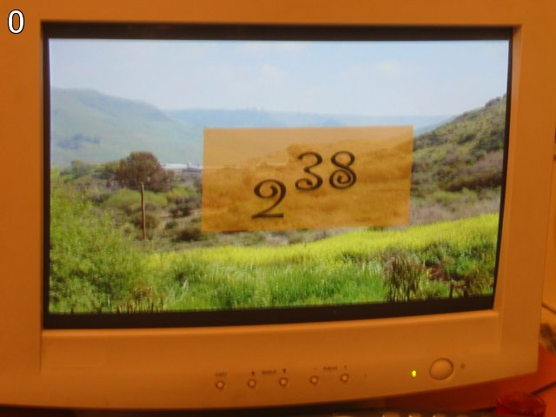

Hint: try to change the URL address.

This is typical of all the webpages for the challenge. I guessed quickly that you should find 2 ** 38 and replace the 0 right before the .html with that value. That works. In python, I used **requests** to see if it was a valid website and then **webbrowser** to actually open the page. On to challenge #1.